**Name :** Hardik Agarwal

**Enroll_No :** 9919103007

**Batch :** F1

**Database System & Web Lab (15B17CI372) WEEK-1 LAB B**

**Q.** Write a SQL query to print all Worker details from the Worker table order by FIRST_NAME Ascending.

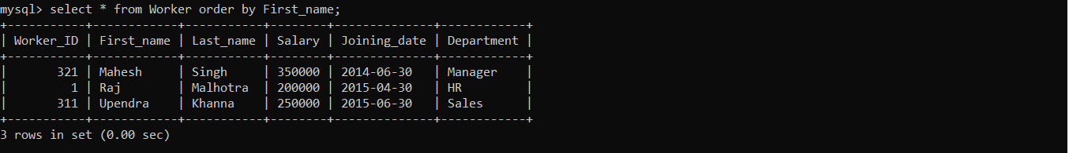

**Q.** Write a SQL query to print all Worker details from the Worker table order by FIRST_NAME Ascending and DEPARTMENT Descending.

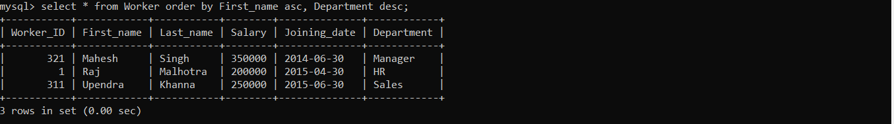

**Q.** Write a SQL query to print details of workers excluding first names, “Vipul” and “Satish” from Worker table.

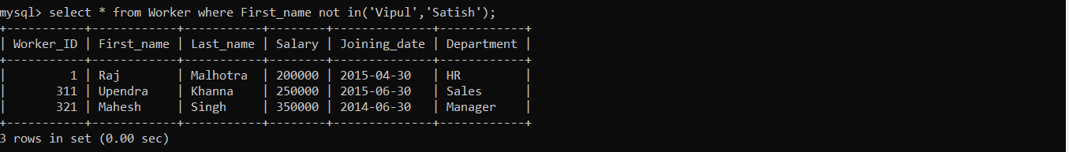

**Q.** Write a SQL query to print details of Workers with DEPARTMENT name as “Admin”.



**Q.** Write a SQL query to print details of the Workers whose FIRST_NAME ends with ‘h’ and contains six alphabets.



**Q.** Write a SQL query to print details of the Workers whose SALARY lies between 100000 and 500000.

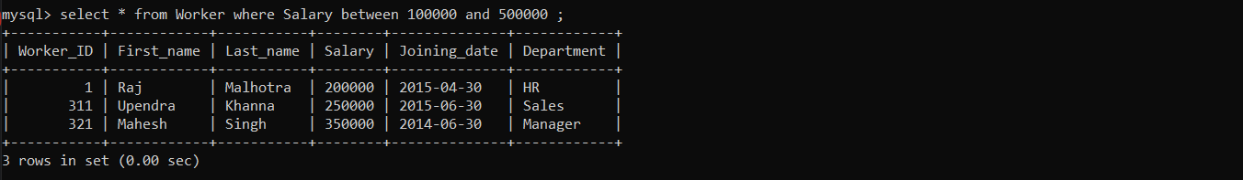

**Q.** Write a SQL query to print details of the Workers who have joined in Feb’2014.



**Q.** Write a SQL query to fetch the count of employees working in the department ‘Admin’.

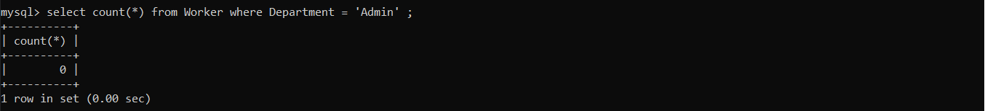

**Q.** Write a SQL query to fetch the no. of workers for each department in the descending order.

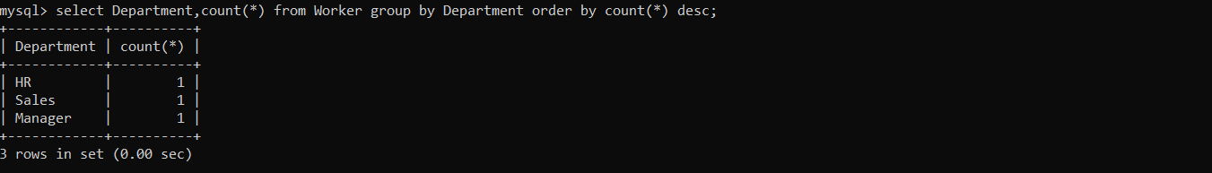

**Q.** Write a SQL query to show only even rows from a table.



**Q.** Write a SQL query to show the top 10 records of a table.

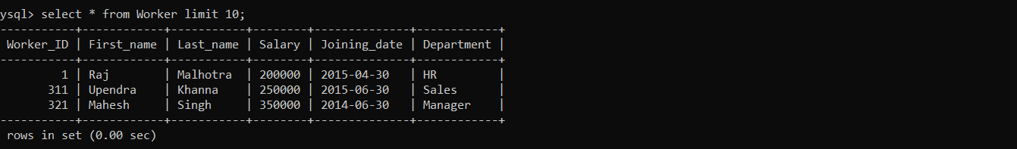

**Q.** Write a SQL query to fetch the departments that have less than five people in it.

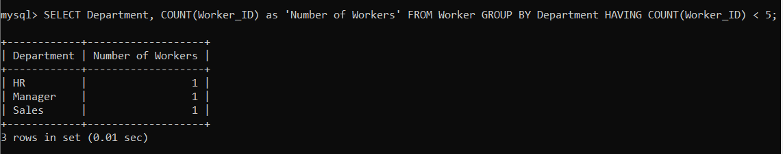

**Q.** Write a SQL query to show all departments along with the number of people in there.

